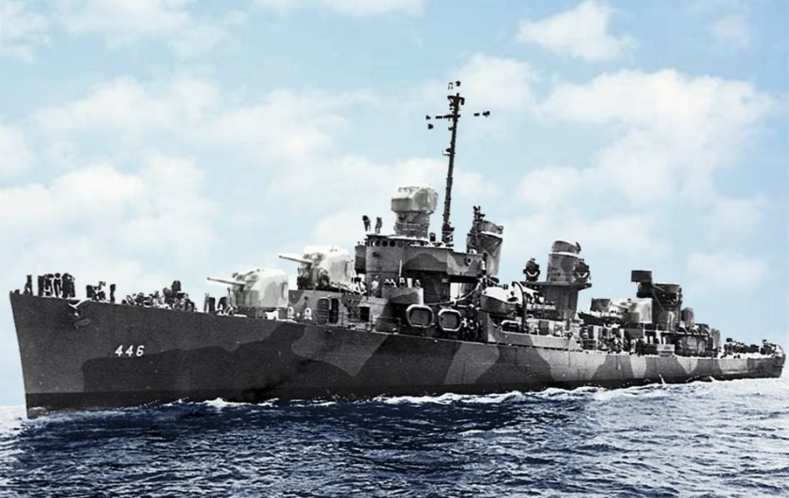
The Fletcher Class Destroyer
Our ship, USS Radford (DD 446), was a Fletcher Class destroyer built by the United States during World War II.
Radford is just one of 175 Fletcher-class destroyers commissioned by The United States Navy between 1942 and 1944, more than any other destroyer class. The class was designed in 1939, as a result of dissatisfaction with the earlier destroyer leader types of the Porter and Somers classes. This new design was generally regarded as highly successful.
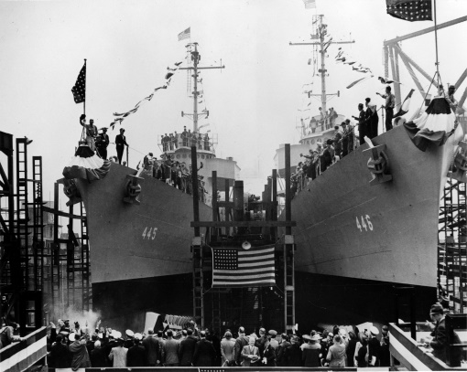
In a massive effort, the Fletchers were built by shipyards across the United States. Radford was built next to the USS Fletcher in Kearney, NJ, and was the fifth Fletcher Class ship to be commissioned. The Fletchers had a design speed of 38 knots (70 km/h; 44 mph) and a principal armament of five 5-inch (130 mm) guns in single mounts with ten 21-inch (530 mm) torpedo tubes in two quintuple centerline mounts. The Allen M. Sumner and Gearing classes were Fletcher derivatives.
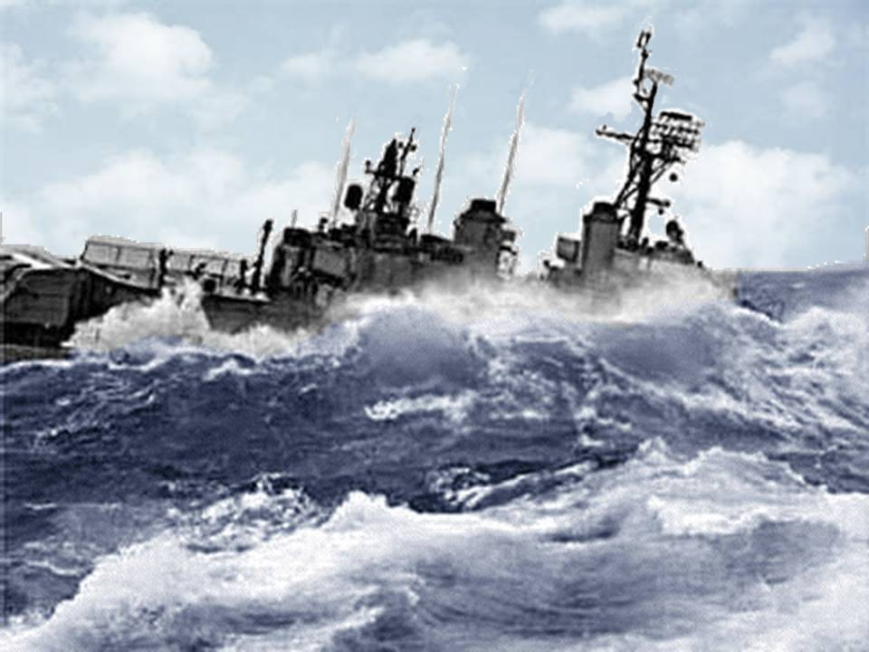
The long-range Fletcher-class ships performed every task asked of a destroyer, from anti-submarine warfare and anti-aircraft warfare to surface action. They could cover the vast distances required by fleet actions in the Pacific and served almost exclusively in the Pacific Theater of Operations during World War II, during which they accounted for 29 Imperial Japanese Navy submarines sunk and numerous other surface ships damaged or sunk. Ten of the Fletchers were lost and six were damaged so badly that they were not repaired. 44 of the ships were awarded 10 battle stars or more while 19 were awarded Naval Unit Commendations and 16 Presidential Unit Citations. Following the war all were decommissioned and placed in reserve. Some Fletchers, including Radford, were re-commissioned and went on to serve during the Korean War and into the Vietnam War.

